Assignment 3

**Modification**: Slight change, we have removed the quantity attribute in medicine entity and added to contains entity as each store separately has quantity. We have updated the table also w.r.t this change.

Simple Queries:

1. List of employee details of Store 1.

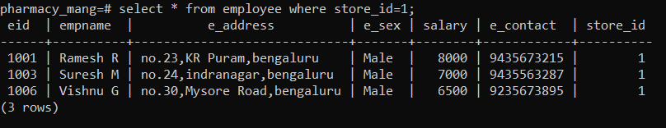

1. List of all the Female patient’s details visited to all the stores.

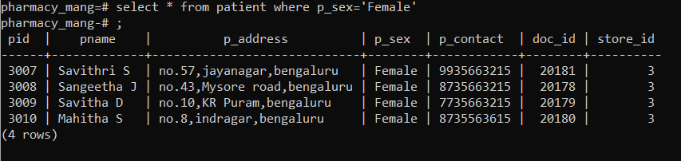

1. List all the drugs which was manufactured by A D pharmaceutical company.

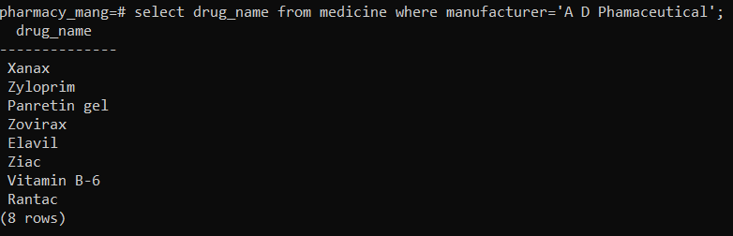

1. List of all the patient details who consulted doctor Satish H M.

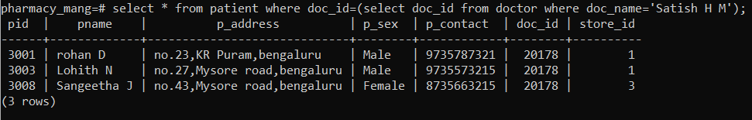

1. List of all the bills generated by store 3.

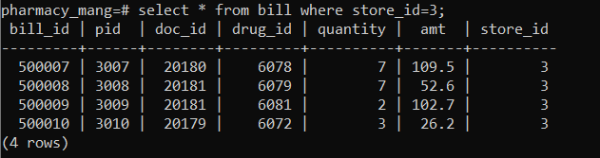

Complex Queries:

1. A employee of Store 2 wants to know the information and availability of the drug named ‘Rantac’ in his store.

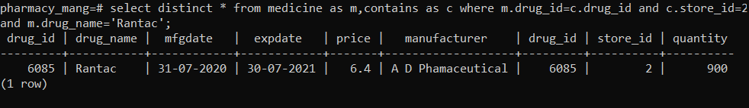

1. List so far collection of money of each store.

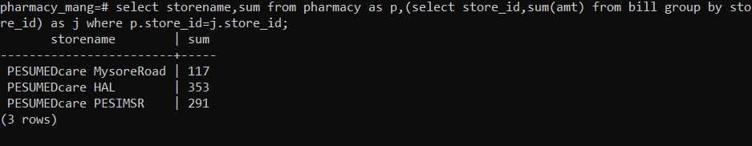

1. List of all the medicines sold by each store.

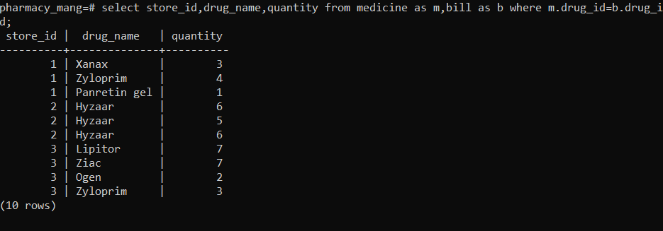

1. List of all the medicines present in store no. 2.

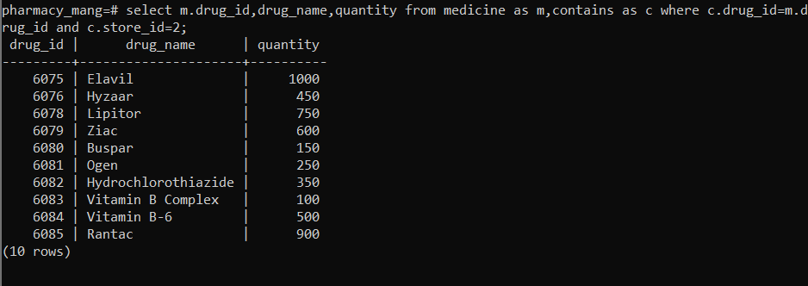

1. List of all doctors associated with each store.

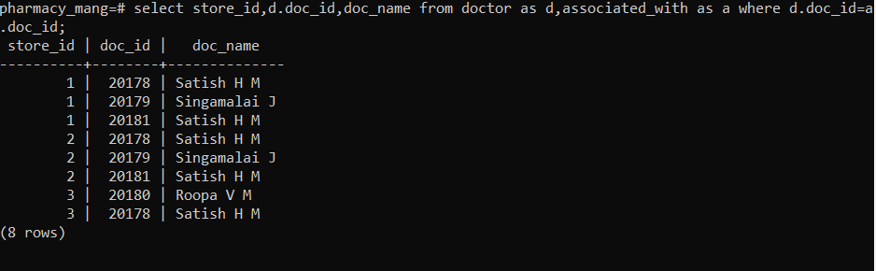

Users with different access privileges:

Different users list.

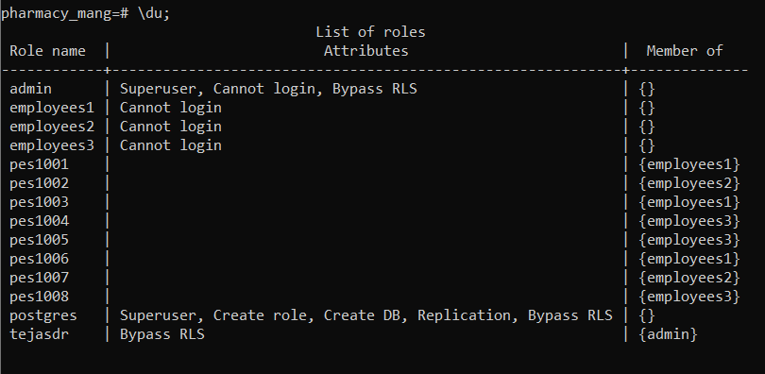

1. Restriction for employees to access only details pertaining to the store they work in.

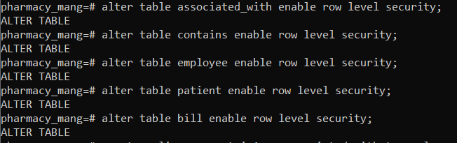

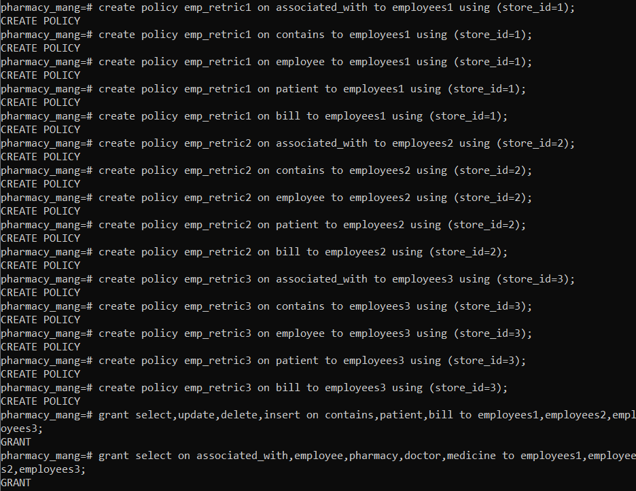

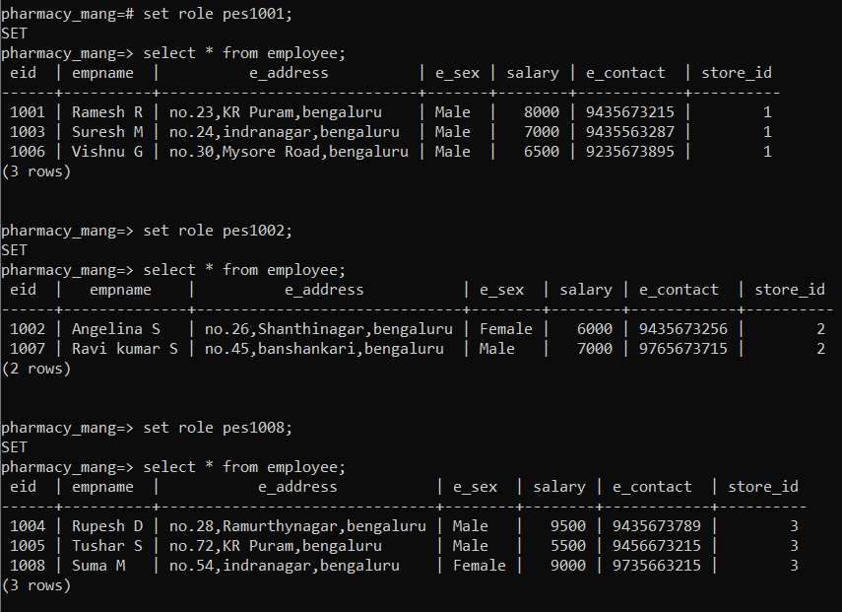

As you can see the user(employee) can access only those rows of the employee table to which store_id he belongs. Similarly the restriction is applied to all the tables.

1. There is no restriction for admin on the database he can access all the data and modify it.



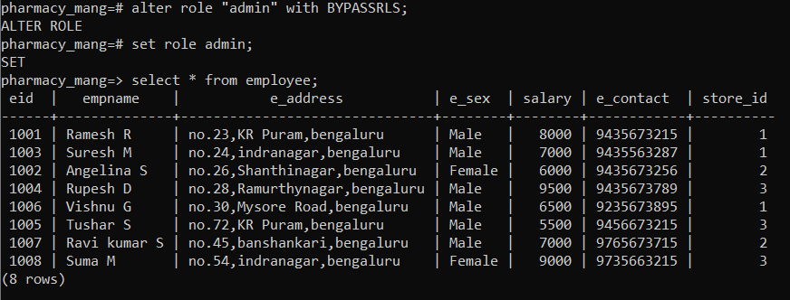

As you can see now all the rows of the employee table is visible to the admin, similarly for all the tables.

Trigger created:

